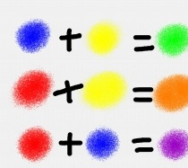

Key Knowledge:
To know that:
> Adding white and black will change the shade.
> The darker the hue is added to the lighter hue when mixing colours.
> Sketchbooks are created to record observations and use them to review and revisit ideas.
> It is important to select an appropriate brush for the task
> I need to hold a paintbrush in a pen grip to use it effectively.
> There are often common themes within an artist’s work.
> The choice of colour in an artists’ work is usually deliberate.
> I can use observations to influence my own work.

What Is Colour?
Year 3
Autumn 1

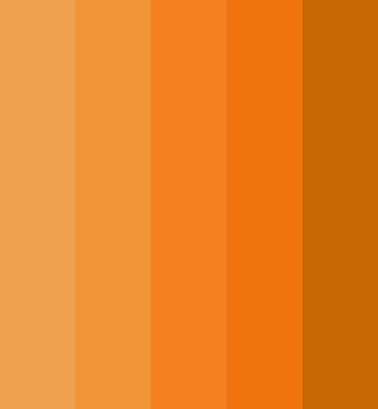
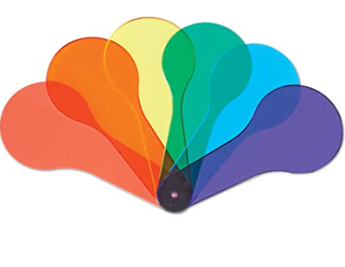
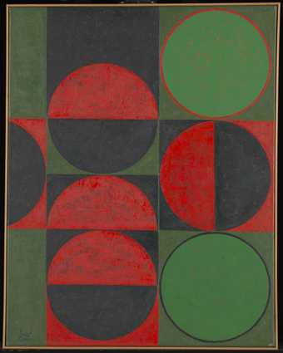
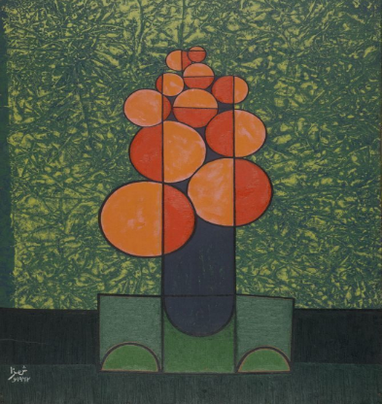
Key Vocabulary:
• Primary colours - are red, yellow and blue. They cannot be made by mixing other colours together. Primary colours are mixed to produce all other colours (hues).
• Secondary colours - are orange, green and purple. These are made by mixing two primary colours.
• Tertiary colours - are red-orange, yellow-orange, yellow-green, blue-green, blue-purple, red-purple. These are made by mixing a primary colour with a secondary colour.
• Mixing - combining more than one colour
• Lighter - a shade of colour that is bright
• Darker - a shade of colour that is deeper
• Shades – are lighter or darker hues
• Hue –all of the primary and secondary colours (black, white and grey are not hues)

