
Key Knowledge:
To know that:
⇒ The school has rules around using computers to keep me and the equipment safe (e.g. I must have permission to use the computer).
⇒ If I see something online which makes me feel uncomfortable I should turn the screen off and report to an adult.
⇒ I must use my username and password to logon to the school network.
⇒ Personal information should not be shared online.

⇒ Personal information includes: full name, date of birth, address, school and telephone number.

⇒ If they feel uncomfortable with anything online, they should inform a trusted adult.

⇒ It is important to only communicate online with people that we know face-to-face.

⇒ There is a difference between 'liking' and 'trusting' strangers, including celebrities; this is especially the case online.

⇒ Real people can be upset by my actions online.

Online Safety
Year 3
Autumn 1


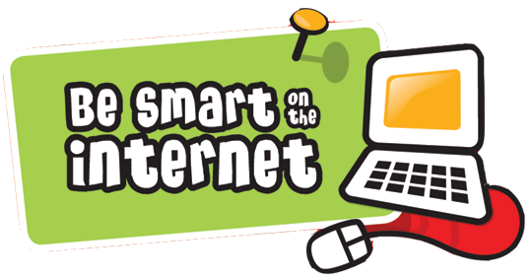
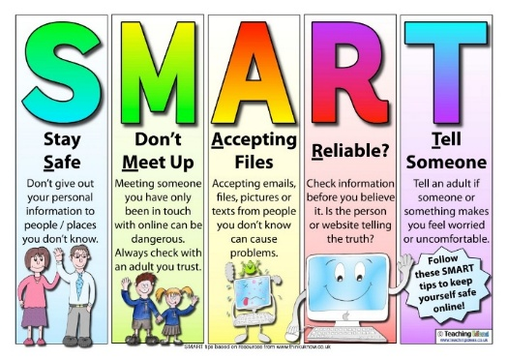
Key Vocabulary:
Computer— a device for working with information.
Screen— the part of the computer which shows what is being looked at.
Mouse— the equipment used to move the arrow on the screen.
Keyboard—the equipment used to enter writing and numbers into the computer.
Permission— asking a trusted adult to be able do something
Password—my personal word to keep my login safe
Private– information that needs to be kept safe
Login— Signing in to a computer or system.
Secure— Something which is safe.
Online— a network that connects millions of computers (the internet)
Offline— Something which is not on the Internet.
Trust—Something or someone you can rely on.
Kind—Being positive and caring towards something/someone.
Bullying—repeated actions which intentionally cause upset or harm
Uncomfortable—Feeling unsure or uneasy about something.

