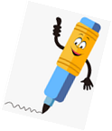

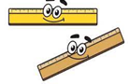
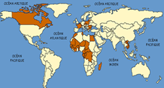

Key Vocabulary:
⇒ ‘un crayon’ means a/one pencil
⇒ ‘un stylo’ means a/one pen
⇒ ‘un bâton de colle’ means a/one glue stick
⇒ ‘une trousse’ means a/one pencil case
⇒ ‘une gomme’ means a/one rubber
⇒ ‘une règle’ means a/one ruler
⇒ masculin / féminin —masculine / feminine
⇒ singulier / pluriel—singular / plural

La Salle De Classe
Key Knowledge:
To know that:
⇒ French nouns can be masculine or feminine e.g. un crayon (masculine), une gomme (feminine)
⇒ Most French nouns can be made plural by adding an ‘s’
⇒ ‘Il y a’ means ‘there is’ or ‘there are’
⇒ ‘Bonjour’ means ‘hello’ and ‘salut’ means ‘Hi’.
⇒ ‘Je m’appelle’ means ‘My name is …’
⇒ 1—10—un, deux, trois, quatre, cinq, six, sept, huit, neuf, dix
⇒ French nouns can be singular or plural.
⇒ The ‘s’ on the end of a French word is usually silent.
⇒ Intonation (going up at the end) can make a sentence into a question in spoken French
⇒ ‘Il y a combien de … ?’ means ‘how many …. are there?’

Year 3
Autumn 1

