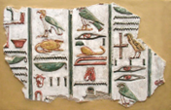
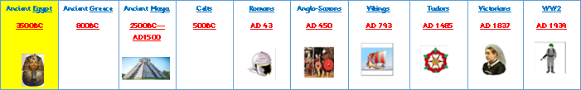

Key Knowledge:
To know that:
⇒ The Ancient Egyptians developed a farming irrigation system - still used around the world today.
⇒ The leader (Pharaoh) was ‘divine’ and made all of the decisions.
⇒ The Egyptians developed a formal writing system called Hieroglyphics.
⇒ Ancient Egypt lasted from 5000 BC — 525 BC.
⇒ The Ancient Egyptian Civilisation was situated in North Africa.
⇒ Ancient Egypt was originally split into two kingdoms - Upper Egypt and Lower Egypt.
⇒ The Egyptian civilisation was and still is centred around The River Nile/ River of Life. (seasons based on flooding). Majority of people lived within 1 mile of the river.
⇒ The Egyptians worshipped many different gods.
⇒ The Egyptians believed in life after death.
⇒ The Egyptians built tombs to bury their dead - most famously the pyramids of Giza.
⇒ Archaeologists use artefacts to learn about Ancient Egypt.
⇒ Egyptians used papyrus paper to write on.
⇒ The Rosetta Stone enabled archaeologists to translate hieroglyphics.

Ancient Egypt
Year 3
Autumn 1

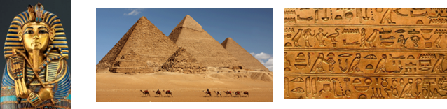
Key Dates / People:
⇒ 5000BC farmers first settled.
⇒ 3200BC King Narmer, also known as Menes, (Upper Egypt) conquered Lower Egypt and built the new capital, Memphis.
⇒ 525BC Persians conquer Egypt, followed by Alexander the Great (Macedonia) and then Rome.
⇒ 1923 Howard Carter’s discovery of Tutankhamun’s tomb.

Key Vocabulary:
Ancient - This means very old and no longer existing.
Civilisation - This word describes the human, social and organisational structure of society
Hieroglyphic - Picture characters used in Ancient Egyptian writing.
Tomb - The place where a dead body is placed.
Artefact - A human-made historical item from the past.
Chronology - This means placing events in the order that they happened.

