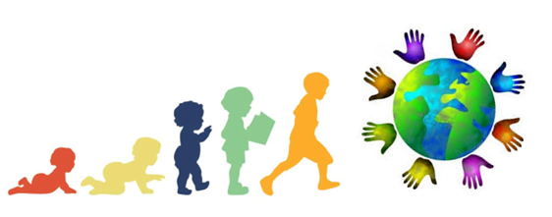
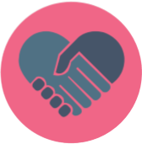

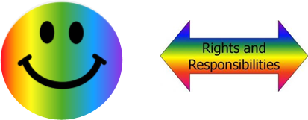
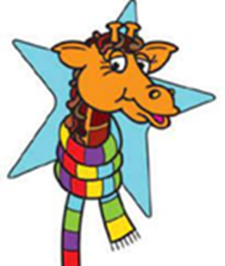

Being My Best
Key Knowledge:
To know that:
• A healthy, balanced diet is a series of meals which have all the nutrients that our bodies need in the right quantities.
• Simple hygiene routines can help to reduce the risk of spreading of infectious illnesses.
• I am responsible for developing my talents and skills.
• A poor, unhealthy diet is made up when not choosing carefully from all the food groups
• Obesity & tooth decay are risks to the body when you eat unhealthily.
• Some infectious illnesses are spread from one person to another.
• People may say kind things to help us feel good about ourselves .
• Some groups of people are not represented as much on television/in the media.
• Working together in a collaborative manner can help everyone to achieve success;
• The brain sends and receives messages through the nerves.
The names of the major internal body parts are: heart, blood, lungs, stomach, small and large intestines, liver, brain
• Food, water and air get into the body and blood by respiration and digestion
• People have different talents and skills.

Year 3
Autumn 1

Key Vocabulary:
balanced diet—a series of meals which have all the nutrients that our bodies need in the right quantities.
healthy— Feeling good and strong in your body and mind.
proteins—a key part of a healthy diet, supporting growth and repair
carbohydrates—a key part of a healthy diet, providing energy
dairy—a food group where milk is the key ingredient
obesity—a condition of being extremely overweight
tooth decay—when teeth deteriorate
infectious—a disease or illness which can spread and cause further infection / disease
hygiene—a way to keep clean and healthy
media—a way of communicating to many people
collaborative—when you co-operate with other people
nerves—cord-like structures which connect the brain to parts of the body
talent—a natural ability to do something well

