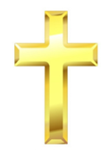
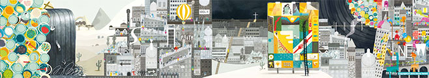

Christianity - The Big Frieze
Key Knowledge:
To know that:
The Big Frieze shows the story/timeline of the events in the Bible.
The Creation Story describes how God created the world.
Adam and Eve were the first humans, created by God.

There are symbols and pictures that represent each part of the Big Frieze.
Christians believe that the Creation Story shows the wonder and power of God.
The story of Adam and Eve was a test from God and links to the ‘Fall of Man’ in the Big Frieze.

Year 3
Autumn 1

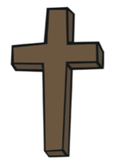
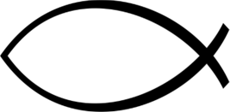
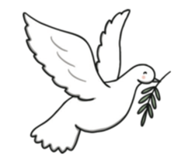
Key Vocabulary:

Big Frieze is the Big Story of the Bible told in pictures, with different headings: Creation, Fall of Man, People of God, Incarnation, Gospel, Salvation, Kingdom of God
Symbols— A mark, sign, or word that represents an idea, object or relationship.
Temptation—A desire to do something, especially wrong or unwise.
Serpent— A large snake, a Biblical name for Satan.
Genesis— The traditional Greek name for the first and best-known book in the Bible, meaning ‘origin’.
Chapter—A division of a book, typically with a number or title.
Christians—A person who has received Christian baptism or is a believer in Christianity.
Christianity—The religion based on the teachings of Jesus Christ.
Old Testament—The first half of the Bible.
Christians—The followers of Jesus Christ.

