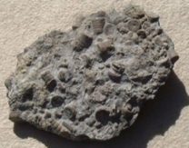

Rocks and Soils
Key Knowledge:
To know that:
⇒ Rock is a hard material made up of one or more minerals.
⇒ Soils are made from rocks and organic matter.
⇒ Fossils are formed when things that have lived are trapped
within sedimentary rock.

There are three types of rock—sedimentary, igneous and metamorphic.
Sedimentary rock is easily worn away and often has fossils and layers.
Metamorphic rock often has minerals and spots of colour.
Igneous rock often has visible crystals.
Sedimentary rock is formed from layers of igneous and metamorphic rock which are layered between organic matter over time.
Metamorphic rock is formed when igneous rocks are subjected to massive heat and pressure.
Igneous rock is formed when molten lava cools.
Fossils provide information about living things that inhabited the Earth millions of years ago.

Year 3
Autumn 1

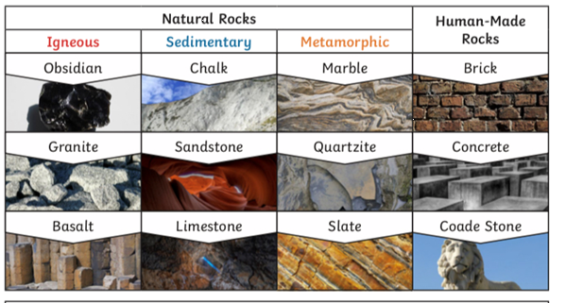
Key Vocabulary:
Rock - a solid mass made up of minerals
Sedimentary - rocks formed by layers of sediment, e.g. chalk
Igneous - rocks formed by a volcano or other source of great heat
Metamorphic - rocks formed by heat and pressure e.g. marble
Eruption - the process of erupting
Molten lava - hot, melted rock that erupts from a volcano
Crystal - a glass-like material that is made when a substance changes from a liquid to a solid. Crystals are often found in igneous and metamorphic rocks
Soil - top layer of the Earth’s surface
Fossil - the remains of a living animal or plant from a long time ago which are embedded in earth or rock
Organic matter - substance that has come from a recently living organism and is capable of decay
Layers - built up by things being laid down in sheets one after the other
Pressure - being pushed with force from multiple directions
Minerals - a solid, naturally occurring inorganic substance
Fair test - a scientific test to answer a question where one factor is changed and everything else stays the same

