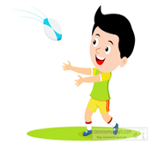
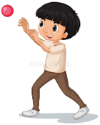

Key Vocabulary:
Send - arrange for the delivery or throw of an object
Accurately—reaching an intended target
Receive—catch, stop or trap an object which has been sent
Awareness—know what is happening around you
Space—an empty area without any opponents or interferences
Tracking—watching a moving object
Key Knowledge:
To know that:
Þ Hold the ball underneath with one hand when rolling
Þ Lunge forward low to the ground to release the ball low to the ground to achieve a roll and not a bounce
Þ Get feet and hands behind the ball to receive it
Þ Hold the ball with one hand when throwing
Þ Throwing hand should point at the target when the ball is released
Þ Create ‘cereal bowl’ or ‘W for winning’ shape with hands before ball arrives
Þ Move away from opponents to find space to receive the ball in
Þ Send/throw/roll the ball towards a team mate who has space around them

Year 3 - Autumn 1 & 2
Sending & Receiving

