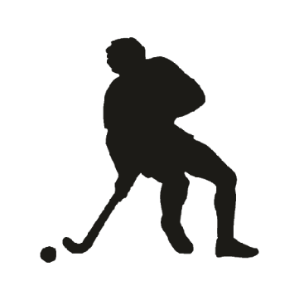
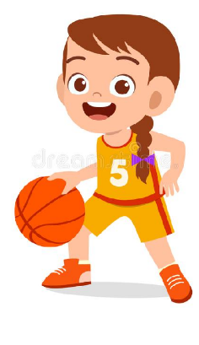

Key Vocabulary:
Dribble—moving an object from one area to another with control
Direction –where the dribbling is moving to
Space- an empty area without any opponents or interferences
Shield—to block or protect your object from an opponent
Awareness- know what is happening around you
Split hands—dribbling an object by changing each hand.
Key Knowledge:
To know that:
Þ ⇒ A hockey stick should be held with two split hands (one at the top and one in the middle)
⇒ A handball should be bounced/dribbled with the fingers and not the palm of the hand
⇒ Change direction quickly to move away from other players and into space
⇒ When dribbling, keep the ball close to the body for more control
⇒ When dribbling, use lots of little touches to keep the ball under control
⇒ The more the head is up and looking around, the more aware a player will be of where the space is
⇒ Dribble into space quickly to receive the ball or create own space
⇒ Standing between an opponent and the ball creates a barrier or shield for the ball

Year 3 - Autumn 1 & 2
Dribbling

