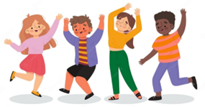

Key Vocabulary:
Þ Expressive-showing emotion or feeling when performing
Þ Dynamics (nature of movement)-the energy, or effort, or force, or weight applied to movement
Þ Stimulus (the starting point for dance)-the starting point or incentive for creative movement.

Key Knowledge:
To know that:
⇒ Dancing at different levels improves a dance.
Þ Mirroring is copying a partner's movements at the same time as them.
Þ A canon in a dance is performing the same movement after one another
Þ Creating and using mind maps can help to develop dance ideas.
Þ The distance between partners in a sequence can be different.
Þ Sequences can follow different pathways.

Year 3 - Autumn 1 & 2
Dance

