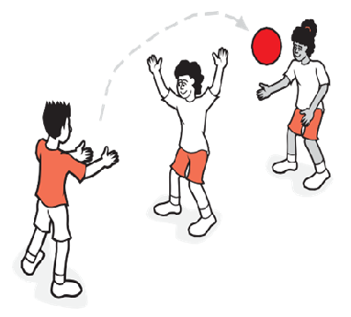
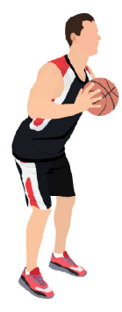

Key Vocabulary:
Awareness-knowing where your opponents and teammates are around you
Scanning-using a quick look to see what is happening all around you
Weight– how ‘heavy’ or how much force to apply when passing a ball
Possession-when you or your team are holding or ‘in possession of the ball’
Ready position-a position used before the ball arrives. Hands out to side, palms facing forwards and knees slightly bent.
Key Knowledge:
To know that:
Þ It is better to receive the ball in space
Þ I should scan around to be aware of where the space
Þ Use short and loud communication to make teammates aware you are ready to receive the ball
Þ It is important to use communication to make teammates aware you are receiving or sending the ball
Þ I need to take up the ‘ready’ position of hands in front of the body and eyes on the ball before receiving the ball
Þ It is most effective to pass to a team member who is in the most amount of space

Year 3 - Autumn 1 & 2
Passing & Space

