

Online Safety
Year 4
Autumn 1

Key Knowledge:
To know that:
Being kind and respectful online makes me a good digital citizen.
I should not share personal information online.
If you reuse someone else’s content, you must give credit to the creator.
I should not meet anyone I meet online, face-to-face.
Content can be reused as long as credit is given to the creator.
I can report bad behaviour that I see online by BLOCKING, REPORTING and TELLING
There are reasons for and against monitoring online behaviour

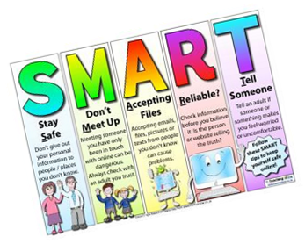
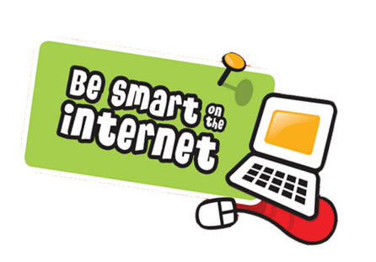

Key Vocabulary:
Online safety—staying safe online
Respectful—feeling or showing respect
Digital citizen—a person who develops the skills and knowledge to effectively use the Internet and other digital technology, especially in order to participate responsibly
Personal information -information about any person, such as information that relates to a person ’s name, health, finances, education, addresses, telephone numbers etc.
Compassion—being sympathetic to someone’s feelings
BLOCK— prevent someone from contacting you online
REPORT— formally providing information about an incident to a website
TELL—make something known to a trusted adult
Content—what is on a website
Creator—the person who made the content
Uppercase—capital letters eg A B C
Lowercase—small letters eg a b c
Symbols– sign that stands for something
Monitoring– checking and keeping a record of something

