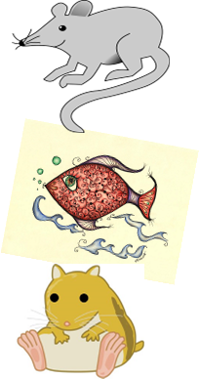
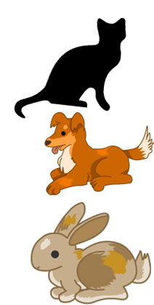
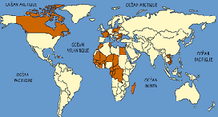
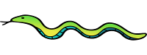

Key Knowledge:
To know that:
Þ Tu as des animaux? means Do you have any animals?
Þ ‘et’ means ‘and’
Þ Some nouns have an irregular plural form (un animal - des animaux / une souris - trois souris)
Þ ‘je n’en ai pas’ means ‘I don’t have any’
Þ irregular' means that something does not follow a pattern

Key Vocabulary:
⇒ 1—31
⇒ un animal—an animal
⇒ un chat—a cat
⇒ un chien—a dog
⇒ un lapin—a rabbit
⇒ un hamster—a hamster
⇒ un poisson—a fish
⇒ une souris—a mouse
⇒ j’ai—I have
⇒ Tu as ..? - do you have …?
⇒ et—and
⇒ mais—but

Les Animaux
Year 4
Autumn 1

