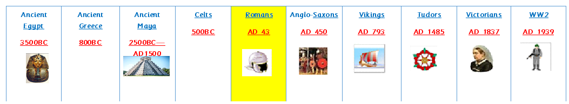

Key Knowledge:
To know that:
⇒ The Romans fought against the Celts in Britain and then ruled over the tribes that were left.
Þ The Roman Empire expanded across most of modern Europe and Northern Africa. They overthrew the Greek Empire.
Þ The Romans brought many things to Britain that we still use today like roads, calendar, laws, concrete, aqueducts and central heating.
Þ The Romans invaded Britain 3 times and were successful on the third time (43AD).
Þ The Roman Era in Britain lasted from 43AD to 410AD.
Þ The Roman leaders collected money through taxes.
Þ The effective organisation and structure of the Roman army enabled the Roman Empire to expand.
Þ The Romans built Hadrian’s Wall to keep out the Picts.
Þ The Romans brought roads, calendar, laws, concrete, aqueducts and central heating to Britain.

Romans
Year 4
Autumn 1

Key Dates / People:
Þ 43AD—410AD Roman Britain
Þ Caesar Augustus
Þ Julius Caesar
Þ Boudicca

Key Vocabulary:
B.C. Before Christ - The period of time before Jesus was born.
A.D Anno Domini - In the year of our lord. Time period since Jesus has been born.
Empire - A group of states or countries ruled by one leader
Democracy - A country or community where every person gets a chance to vote on important decisions, including those who govern the country.
Republic - A form of government where the people elect, or choose, their leaders.
Infrastructure - Basic physical systems of a country’s population, such as roads, water, sewage, utilities (electricity, gas). These systems are essential to allow everybody to be productive.
Architecture - The design of buildings.
Rebellion - A group of people who fight against a particular rule/decision made by the government.
Government - The people who decide how things happen in a country.

