

Year 4
Autumn 1

Key Knowledge:
To know that:
• The names of the strings from top to bottom are G, C, E, A (Greedy Cats Eat Anything)
· There are different parts of a ukulele: frets, tuning pegs, body, strings, bridge, body, neck.
· To form a chord, you use your left hand to hold the string down on the correct fret.
· The right hand is used to strum the strings.
· Open strings are when a string is not held down.
· Upstrums are where you move your finger both up and down the string to create a rhythmic pattern.
· Chord diagrams are another form of music notation. They show you which strings to hold down and which strings are open strings. They also tell you which number finger to use to hold down the string.
· Strumming is an up and down movement over the strings, using the finger or thumb.
· The ukulele is held across the body and your left hand holds the neck. of the instrument.

Ukulele
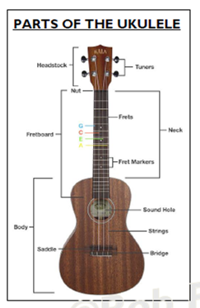
Key Vocabulary:
Melody— the main tune.
Harmony—a musical part that fits with and enhances the melody / tune.
Rhythm—different patterns of long and short sounds.
Chord—more than one note is played at the same time.
Bar— a section of music made up of a certain amount of beats
Tempo—how fast or slow the music is
Chord Diagram—a diagram that shows how to play a chord.
Strumming pattern— a pattern produced by an up and down movement on the strings.
Swing (shuffle) rhythm— a rhythm that is heard in rock, blues and jazz.

