
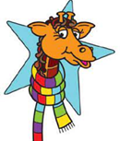
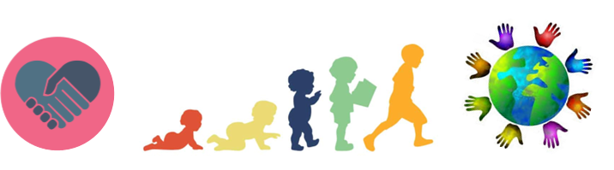

Key Knowledge:
To know that:
· Everyone is unique in different ways
· The body gets energy from food, water and oxygen and that exercise and sleep are important to our health;
· There are ways in which they can contribute to the care of the environment (using some or all of the seven Rs);
· There are times when they will make the same choices as their friends and times when they will choose differently
· Some choices they make for themselves and some choices others make for them;
· There are different ways people can support the school community;
· People have different qualities and attributes and these can help them to support the school community.

Being My Best
Year 4
Autumn 1

Key Vocabulary:
attributes—a quality or feature of a person’s character
community— a group of people who live in the same place or share something in common.
unique—being the only one of its kind; unlike anything else
environment—the surroundings or conditions in which a person, animal, or plant lives
talent– a natural ability to do something well
personality—characteristics or qualities that form an individual's character
appearance—the way someone or something looks
mutual respect—treating other people with dignity and recognising their value
environmental sustainability—the ability for the planets natural environment to survive and thrive
benefits—an advantage or profit gained from something

