
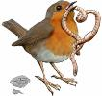

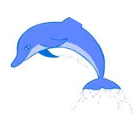
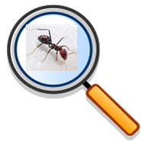

Key Knowledge:
To know that:
• A classification key asks questions to group living things.
· Living things can be identified using the 7 life processes (MRS GREN) which are: movement, respiration, sensitivity, growth, reproduction, excretion & nutrition.
· Vertebrates can be classified into five main groups: mammals, fish, birds, amphibians and reptiles.
· Living things are either plants or animals.
· The main difference between plants and animals is that plants can make their own food (photosynthesis).
· Animals are either vertebrates (with a backbone) or invertebrates (without a backbone).
· Mammals are warm blooded; have hair or fur; have mammary glands and are breast-fed; and give birth to live young.
· Amphibians are cold blooded, have moist skin, lay their jelly-like eggs in water and can live on both land and in water.
· Reptiles are cold blooded, have dry scales and lay leathery eggs on land, Fish are cold-blooded; have gills, scales and fins; and lay jelly-like eggs in water.
· Birds are warm blooded: have feathers and wings; and they lay hard-shelled eggs on land.

Classification
Year 4
Autumn 1

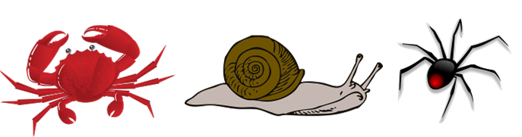
Key Vocabulary:
Respiration—the act of breathing
Sensitivity— reacting to changes in the surrounding environment
Excretion—getting rid of waste products from the body
Reproduction - the process by which living things create young or offspring.
Nutrition— the process of eating healthy food for living and growing
Classification— the process of sorting items into groups
Classification key— a series of questions used to classify a living organism
Characteristic— a special quality or trait that makes a person or animal different or the same as others
Warm-blooded—blood is kept at a temperature by the body
Cold-blooded—the temperature of the blood is dependent on the environment
Vertebrates—animals with backbones
Invertebrates—animals without backbones

