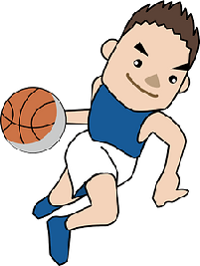
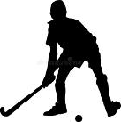

Key Vocabulary:
Possession—when you or your team have the ball
Advantageous - giving yourself an advantage over an opponent
Spatial awareness - knowing if there is space around your body
Centre of gravity-the point where the weight is even on all sides
Touch strength-how much force to allow when touching the ball
Key Knowledge:
To know that:
⇒ When dribbling, ensure time is spent looking at the ball but also at what is in front and around
⇒ A handball should be pushed when dribbling as opposed to hit or slapped
⇒ Bent the knees slightly to get lower to the ground which will allow for a quicker change of direction
⇒ When dribbling, if there is more space, use larger/bigger touch to travel through the space quicker
⇒ Keep the ball moving with lots of little touches when shielding the ball from an opponent
⇒ Only pass to a teammate who has enough space around them and if they are in a more advantageous position than if you continued to dribble

Year 4 - Autumn 1 & 2
Dribbling

