
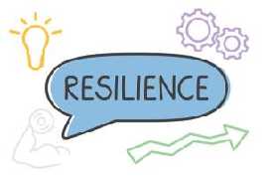

Key Knowledge:
To know that:
Periods of frustration, stress or disappointment are completely normal and are experienced by professional sportsmen and sportswomen regularly.
Use a couple of taught strategies to keep emotions under control and so they don’t affect performance.
Use multiple attempts, if needed, to learn a new skill or achieve a target whilst remaining positive throughout
Welcome trying new things and avoid feeling nervous or worried about these new experiences
Personal growth/best is more important and valued than comparing performance against others
Being honest with yourself when identifying strengths/areas for improvement can help performance
By practising more, a skill can be learnt quicker

Key Vocabulary:
- Reflection-thinking about the past and how you could improve performance
- Stress-normal response to life's changes, pressures, and challenges
- Honesty-tell yourself the truth about how you have performed
- Control-being able to feel a certain way without it being overpowering
Year 4 – Autumn 1 & 2
Resilience

