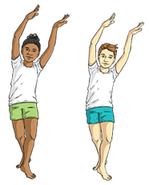
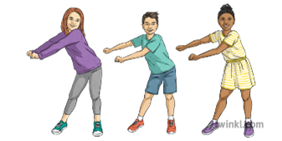

Key Vocabulary:
Expressive - Showing emotion or feeling when performing
Repetition - A movement or motif are repeated exactly for. emphasis or to gain interest
Dynamics—Nature of movement
Unison - Two or more dancers performing the same movement at the same time
Compose - Thinking and putting together a dance
Tradition - Local dancing tradition, often strongly connected with local musical forms and/or local beliefs.

Key Knowledge:
To know that:
There are different styles of group dance movements: action and reaction, question and answer.
There are different dance styles each with their own

Year 4 - Autumn 1 & 2
Dance

