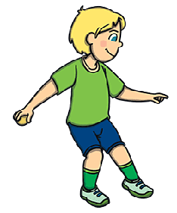
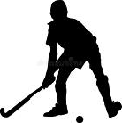

Key Knowledge:
To know that:
Þ Spread fingers underneath the ball when rolling
Þ Bend knees so the body and hands are almost touching the ground when receiving a rolling ball
Þ Use small sidesteps or similar to ensure the hands and body are behind the ball when receiving it
Þ Use ‘cereal bowl’ when ball is received below waist height and use ‘W for winning’ when ball is being received above waist height
Þ Step towards target to increase distance of throw
Þ Use a variety of movements and speeds to create space to receive the ball in
Þ Make the decision of who to send/throw/roll the ball to quickly

Key Vocabulary:
Spatial awareness—knowing if there is space around your body
Consistency—sending or receiving the ball well repeated times
Decisive –choosing what to do quickly
Tracking-watching a moving object and making movement adjustments accordingly
Decision making—deciding when to send the object
Year 4 - Autumn 1 & 2
Sending & Receiving

