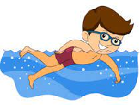
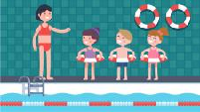

Key Vocabulary:
- Front crawl-swimmer faces downwards and moves their arms alternately
- Tread water-float in an upright position by moving their legs slightly
- Backstroke-performed on the back with the arms lifted alternately out of the water in a backward circular motion and the legs extended and kicking. Breaststroke-arms are pushed forwards and then swept back in a circular movement
- Feet first scullyling - Streamline position, on your back. Flat body and making small hand movements to project forwards
- Head first scullying - Streamline position, on your back. Flat body and figure of 8 movement to move head first.
- Treading water - To keep your body vertical while staying on the spot
Key Knowledge:
To know that:
Þ When doing front crawl, arms enter the water and pull back to the ‘pocket’
Þ Backstroke - arms pull back to ‘pocket’ underneath the water
Þ Breaststroke - both arms pull together when in the water towards the body
Þ In front crawl, legs kick slightly under the water
Þ In backstroke, arms enter the water little finger first
Þ When swimming backstroke, I need to maintain a steady kick underneath the water throughout
Þ When swimming breaststroke, arms enter the water with fingers and hands together
Þ When swimming breaststroke, I need to bring legs towards the body pressing my heels together
Þ Breathing out of the water should take place every 2-4 strokes
Þ Wearing additional clothes in the water will make your body a lot heavier which will make it harder to swim

Year 4 – All year
Swimming

