

Online Safety
Key Knowledge:
To know that:
Þ If a stranger contacts me online, they may want to cause me harm, so I should block them and not reply.
Þ If I receive online communication which makes me feel uncomfortable, I should BLOCK, REPORT (button, CEOP) and TELL (a friend, trusted adult, police or Childline).
Þ Bullying is repeated, one-sided behaviour which intentionally causes upset, whereas joking and teasing are not intended to cause harm
Þ Many free apps or services may read and share private information (e.g. friends, contacts, likes, images, videos, voice, messages, geolocation) with others.
Þ I should support others (including those who are having difficulties) online.
Þ I can use the button on every online platform to block users who are strangers and/or behave in a way which makes me feel uncomfortable.

Year 5
Autumn 1

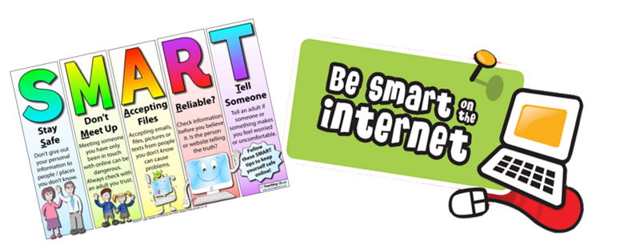

Key Vocabulary:
BLOCK: To stop a computer reaching something on the internet, to stop a program running, or to stop someone from contacting you on a chat service. Websites that are blocked can’t be viewed on screen; emails that are blocked will be automatically redirected into your junk mail; chat programs that are blocked can’t be started; people that are blocked cannot reach you online through that particular chatting service.
REPORT: using the ‘REPORT’ button on a particular website, app or online programme to report unacceptable online behaviour to avoid them continuing.
TELL: If you experience something that makes you feel uncomfortable online, tell an adult that you trust – they can help you.
Stranger danger: The concern that an unknown person might do some harm to a child. This is seen as a significant problem for online activities like chat and email as it can be easy for people to pretend to be someone else online.
Private information: Personal information is any information that relates to a specific person. Some of the most obvious examples of personal information include someone's name, home address, email address, phone number, and school.
CEOP: CEOP is a law enforcement agency and is here to help keep children and young people safe from abuse online.
Childline: Childline is a free, private and confidential service where you can talk about anything. We’re here for you online, on the phone, anytime 0800 1111
Cyber bullying: Bullying behaviour which takes places through the use of electronic means, such as through e-mail, mobile phones or posts on a social network.
Abuse: Abuse is when someone causes us harm or distress. It can take many forms, ranging from disrespect to causing someone physical or mental pain

