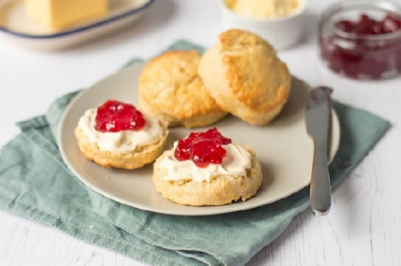

Key Knowledge:
To know that:
- We use our fingertips (a cooler part of our hands) to rub butter into flour.
- We mix or combine ingredients of a similar texture first before adding
ingredients of a different texture.
- We add the liquid a little at a time when combining with other ingredients.
- Ingredients must be kept in the appropriate conditions otherwise our food will become contaminated (particularly ingredients for scones that need to be kept refrigerated).
- Accurate weighing and measuring is needed to make a successful recipe
- We must preheat an oven so that we are cooking at the correct temperature all the time (otherwise it may not cook correctly or will take longer)
- Brushing the top of the uncooked scone e.g. with milk will change the appearance
- Using a cooling rack to cool the scone before putting it in a container means that it does not steam and go damp.

Scone Making
Year 5
Autumn 1

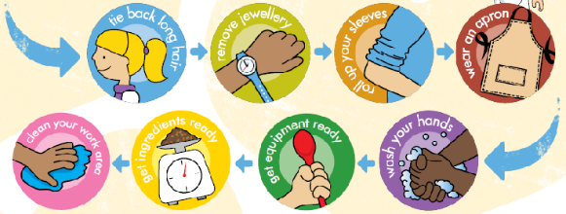
Key Vocabulary:
Recipe: a list of ingredients and instructions for making a food dish. Scone: a small cake made from flour and fat, usually eaten with butter.
Design brief: a set of instructions for a project outlining its purpose. Hygiene: maintaining health and preventing disease, especially through cleanliness.
Method: a particular way of doing something.
Design: a plan or outline showing how something is to be built or carried out, or the way that something is put together.
Sieve (verb): to put flour through a sieve to remove all of the lumps. Cooling rack: a rack used to place biscuits to cool down once they have come out of the oven.
Mixing bowl: the bowl used to mix all your ingredients together before baking in the oven.
Flour dredger: a container used to hold and sprinkle flour.
Palette knife: a very wide, flat knife that is used to smooth over mixture or can be used like a spatula to remove biscuits from a tray Baking parchment: sometimes called grease-proof paper.
Paper that is used to line the baking tray before your biscuits go in the oven

