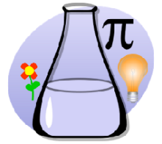

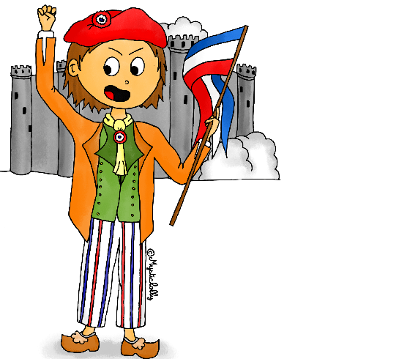

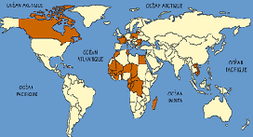

Þ J'aime - I like
Þ J'adore - I love
Þ Je n'aime pas - I don't like
Þ Je déteste - I hate
Þ et - and
Þ mais - but
Þ pourquoi? - why?
Þ car - because
Þ super - brilliant
Þ facile - easy
Þ nul - pointless / useless
Þ difficile - difficult
Þ intéressant - interesting
Þ ennuyeux - boring

Key Vocabulary:
Þ Le dessin - Art
Þ Le français - French
Þ La géographie - Geography
Þ La technologie - Science
Þ La lecture - Reading
Þ La musique - Music
Þ L’anglais - English
Þ L’histoire - History
Þ L’informatique - Computing
Þ L’éducation physique - P.E.
Þ L’éducation religieuse - R.E.
Þ Les maths - Maths
Þ Les sciences - Science

Key Knowledge:
To know that:
Putting ‘ne’ before a verb and ‘pas’ after a verb makes it negative
You can form an opinion in French by using ‘C’est + adjective’ e.g. C’est fantastique
Adjectives do not need to agree after ‘C’est’ i.e. C’est ennuyeux
· ‘Je préfère’ means ‘I prefer’
· ‘Car ’ means ‘because …’

Au Collège
Year 5
Autumn 1

