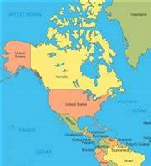
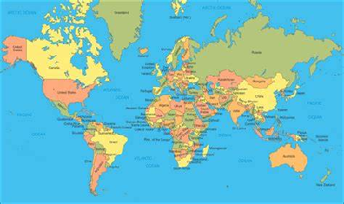

North America
Key Knowledge:
To know that:
· North America is the third largest continent
· North America is in the Northern Hemisphere
· North America is divided into 5 physical regions
· The largest country by area is Canada
· The smallest country by area is Grenada
· The most populated country is USA; the most populated state being California.
· The USA is divided into 50 states
· The oceans/seas surrounding North America are the Atlantic, Pacific, Caribbean and Arctic.
· The 5 largest countries and their capital cities are Canada (Ottawa), USA (Washington), Mexico (Mexico City), Nicaragua (Managua) and Honduras (Tegucigalpa)
· The 5 physical regions are: Mountainous West, Great Plains, Canadian Shield, varied Eastern region and the Caribbean.

Year 5
Autumn 1

North American countries:
United States of America Cuba Bahamas
Canada Haiti Barbados
Mexico Jamaica Grenada
Guatemala Dominica
Belize Dominican Republic
Honduras Antigua and Barbuda
El Salvador Trinidad and Tobago
Nicaragua Saint Lucia
Costa Rica Saint Kitts and Nevis
Panama Saint Vincent and the Grenadines

Key Vocabulary:
Þ continent - a mass of land usually made up of a number of countries
Þ capital city — the administrative centre of a country where the government is based
Þ borders - where 2 countries meet or the edge of a country. Borders can be natural (eg sea, river, mountains) or manmade (eg wall).
Þ regions - part of a country that is defined by a specific characteristic eg weather
Þ ocean - a large expanse of sea
Þ river - a large natural stream of water flowing in a channel towards a lake or sea
Þ mountain - a natural land form on the Earth’s surface that rises up, higher than 600metres, from the surrounding land
Þ Northern Hemisphere - land and sea north of the Equator
Þ population - the number of people living in a country

