

Key Knowledge:
To know that:
· A chord progression is a sequence of chords….eg. C to F to G7
· Different chords can be made by holding down different strings, on different frets.
· A strumming pattern is a pattern used to make a rhythm.
· Chord diagrams allow us to work out how to form a chord and is a type of musical notation.
· Holding our hand over the strings and stopping the sound, is called damping.
· If we arch our fingers over the strings, the chords have a clearer sound.
· The 12 bar blues chord progression is made up of chords, C, F and G7.
· To read a chord diagram, we need to know the name of the strings and count which fret to place the fingers in.

Year 5
Autumn 1

Ukulele
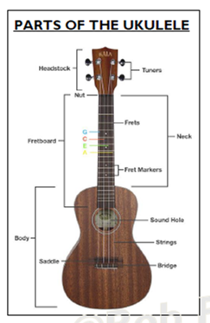
Key Vocabulary:
Melody— the main theme/tune of a piece.
Harmony—A musical part that fits with and enhances the melody / tune
Rhythm—a repeated pattern of notes)
Chord—more than one note is played at the same time.
Bar— a section of music made up of a certain amount of beats.
Tempo—how fast or slow the music is.
Chord Progression— a change from one chord to another.
Chord Diagram—a diagram that shows how to play a chord.
Arrangement—how a piece of music is organised.
Strumming pattern— a pattern produced by an up and down movement on the strings.
Swing (shuffle) rhythm— a rhythm that is heard in rock, blues and jazz.

