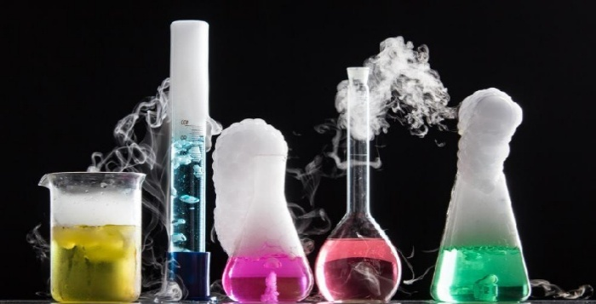

Properties & Changes Of Materials
Key Knowledge:
To know that:
- A reversible change is one where a material can be returned to its original state.
- An irreversible change is one where a material cannot be returned to its original state
- A solution is a combination of a liquid and a dissolved solid.
- Comparative and fair tests can be used to group everyday materials by their properties, including their hardness, solubility, conductivity (electrical and thermal), and response to magnets.
- A conductor is a material or device which is able to transmit a property through it. E.g. An electrical conductor allows electricity to flow through it.
- An insulator is material or device which is not able to transmit a property through it. E.g. A heat insulator doesn’t allow heat through it.
- A mixture is a combination of two or more different materials.
- If a solid dissolves in a liquid it is said to be a soluble material.
- Mixtures can be separated through filtering, sieving or evaporating.
- A solution can be heated to evaporate the liquid and leave the solid.
- Everyday materials, such as metals, wood and plastic, are chosen for their uses due to their properties based on evidence from comparative and fair tests.
- Reversible changes of state include freezing, melting and evaporation, dissolving and mixing.
- Irreversible changes include burning, rusting and the action of acid on bicarbonate of soda.

Year 5
Autumn 1 & 2

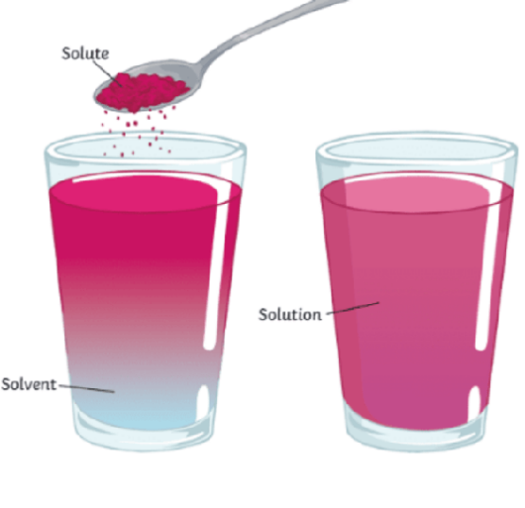
Key Vocabulary:
- Conductor — A material or substance which allows electricity (electrical conductor) or heat (thermal conductor) to pass through it.
- Insulator — A material or substance which does not allow electricity (electrical conductor) or heat (thermal conductor) to pass through it.
Thermal—relating to heat
- Reversible change—A reversible change is a change that can be undone or reversed.
- Irreversible change—A change is called irreversible if it cannot be changed back again. In an irreversible change, new materials are always formed. Sometimes these new materials are useful to us. Burning and rusting are examples of irreversible changes.
- Solution— a combination of a liquid and a dissolved solid.
- Soluble—a solid which can be dissolved. Insoluble—a solid which cannot be dissolved.
- Dissolving—when a solid breaks down in a liquid so you can no longer see it.
- Mixture—A mixture contains two or more substances that are not chemically combined.
- Filter— to pass a mixture through a device to separate unwanted material.
- Sieve—a utensil used for separating different sized solids or solids from a liquid.

