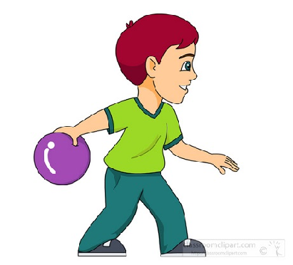
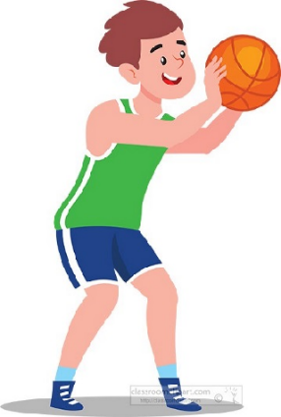

Key Knowledge:
To know that:
Using quick looks all around you helps you know where the space is
Ready position of hands out in front and knees slightly bent should be used before the ball is travelling
An overarm throw can be less accurate but better at travelling a further distance
I should step slightly or lean towards the ball when catching it
An underarm throw can be more accurate but more effective for achieving a throw which travels a shorter distance

Key Vocabulary:
Lean - move body and hands towards the ball when receiving
Body position - where your body is facing
Effective - a throw which is sent with the correct amount of force, speed and direction
Decisive – choosing what to do quickly
Year 5 - Autumn 1 & 2
Sending & Receiving

