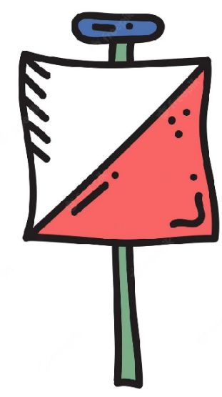
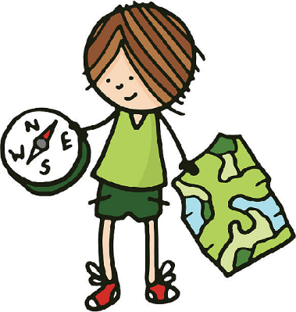

Key Vocabulary:
Critically reflect - thinking in an honest way about what went well & what didn’t
Anagram - letters from a word spelt in the wrong order
Outdoor Adventure Activities
Year 5 - Autumn 1 & 2
Key Knowledge:
To know that:
Þ Always keep the map orientated and move my body around the map instead of turning the map.
Þ A small feature near the control should be identified first to help find the control quicker.
Þ It is important to reflect upon your own and everyone’s ideas to make the best informed decision possible
Þ It is important to study the map carefully when multiple controls are near each other
Þ All man-made features are black on a map

