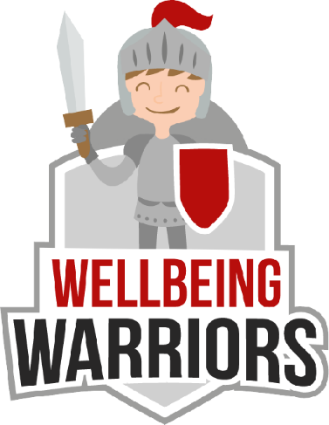
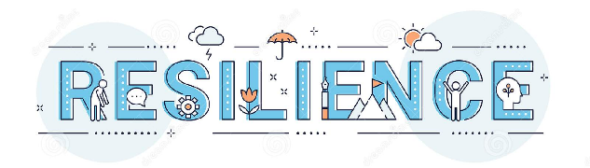

Key Vocabulary:
Current ability - how well you can do a skill however this can improve with practise.
Marvellous mistakes - doing something wrong allows us a chance to learn and improve
Strategy - a plan or way of getting success. It’s good to try different ways
Present - thinking about what’s happening now and not worrying about the past or future
Key Knowledge:
To know that:
Þ Personal growth/best is more important than comparing against others
Þ Having a growth mindset means you can improve at anything
Þ Reflecting after performance helps me to learn how to improve
Þ Periods of frustration, stress or disappointment are completely normal and are experienced by professional sportsmen and sportswomen regularly.
Þ A growth mindset uses the power of the word 'yet'

Resilience
Year 5 - Autumn 1 & 2

