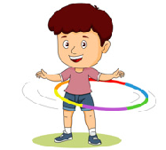
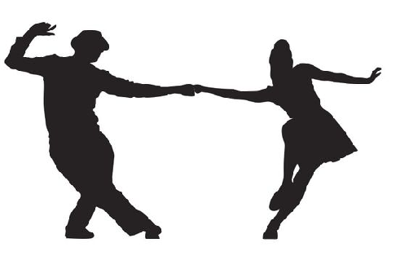

Dance
Key Vocabulary:
Repetition-movement or motif are repeated exactly for. emphasis or to gain interest
Gesture-body moved (especially hands or feet) to share feeling
Motif-A single movement or short phrase of movement which expresses the style or the theme of the dance.
Structure-he way in which movement is organised and shaped to create a dance (for example, ABA)
Year 5 - Autumn 1 & 2
Key Knowledge:
To know that:
Þ Unison means dancing the same movement at the same time.
Þ A change in direction can create interest in a dance.
Þ The order of dance movements in a sequence can change its overall effect.
Þ A sequence of movements can be repeated in a different order to create longer sequences.
Þ Dance sequences can be extended.
Þ Dance movements can happen in different directions.
Þ Chance choreo is when a dance is created by deciding the order of a sequence randomly. e.g. by rolling a dice.

