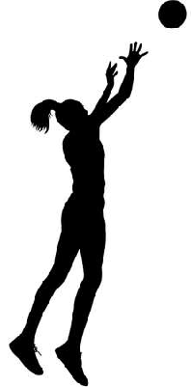
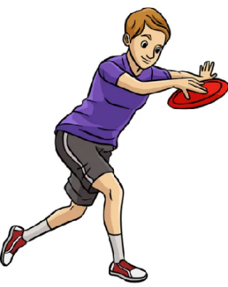

Key Vocabulary:
Pass selection - choosing to pass to a teammate who is in space away from opponents and/or a better position than yourself to score a goal/point
Positional awareness - knowing how to use your ball to increase your chances of receiving the ball
Spread out - as a team moving so that each player has their own space and is away from teammates but not too far away so they wont be involved with the ball
Side on - standing so a side of your ball is facing the ball. This allows you to know where the ball and your opponent are at the same time.
Key Knowledge:
To know that:
Þ I should use varying movements to create space away from a defender
Þ I should pass to a teammate quickly when they are in space to avoid giving defenders time to take up effective defensive positions
Þ A frisbee is caught using the crocodile catch
Þ It is important to use sharp and concise communication in advance to make teammates aware when you are ready to receive the ball
Þ It is effective to have a side on position when defending so you aware of where the opposition and ball both are

Passing & Space
Year 5 - Autumn 1 & 2

