

Key Knowledge:
To know that:
Þ Things shared privately online can have unintended consequences for others
Þ There are different ways to report online bullying depending on the context
Þ It is important to continue asking until I get the help needed.
Þ I should record evidence of online bullying to share with a trusted adult, through a screen shot, print screen, copying and pasting or forwarding.
Þ I must not share inappropriate images of myself or my friends online, even if I have their permission.
Þ I can reduce the risks of using technology on my eyesight, posture, diet, sleep, mood and concentration by taking regular breaks, exercising, setting time limits and using good lighting.

Online Safety
Year 6
Autumn 1

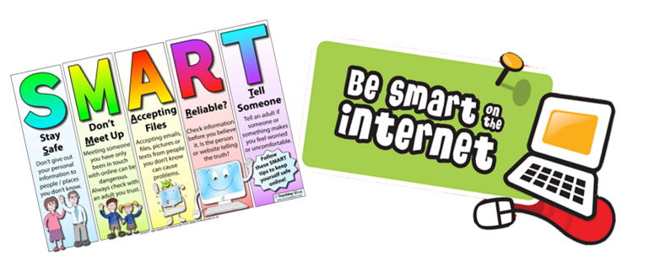

Key Vocabulary:
Inappropriate – not suitable behaviour or actions Consequence – a result of something happening
Social media – websites and applications where users can share content
Report – formally providing information about an incident to a website
Block – prevent someone from contacting you online Evidence – facts or information which is used to support a point
Screenshot – a picture taken of how a screen looks at a certain moment
Forwarding – sending information received on technology to someone else

