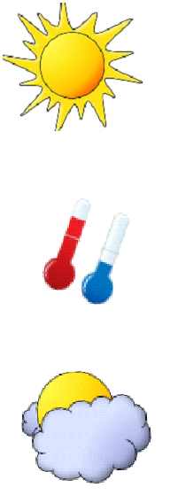
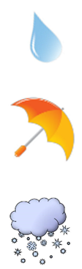
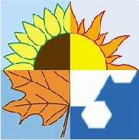

Key Knowledge:
To know that:
Þ When used with weather, ‘il fait’ means ‘it is’ (not it does) e.g il fait du soleil - it is
sunny
Þ ‘Quelquefois’ means ‘sometimes’; ‘souvent’ means ‘often’.
Þ Locations and the seasons can be used as fronted adverbials when discussing the weather e.g. au printemps—in Spring
Þ You can put two types of weather together by using the conjunctions ’et’ and/or ’mais’
Þ One way of forming a question is by inverting the subject and verb e.g Quel temps fait-il?
Þ Always use the word à before a town i.e à Poole, to describe in which town the weather is

Key Vocabulary:
Quel temps fait-il? - What’s the weather like?
Il pleut (it’s raining) il neige (it’s snowing) il fait du soleil (it’s sunny), il fait beau (it’s a nice day), il fait chaud ( it’s hot) il fait froid (it’s cold)
à (+ town) - in (Poole)
quelquefois—sometimes
souvent—often
en hiver (in Winter) , en automne (in Autumn), en été (in summer) au printemps (in spring)

Le Temps
Year 6
Autumn 1

