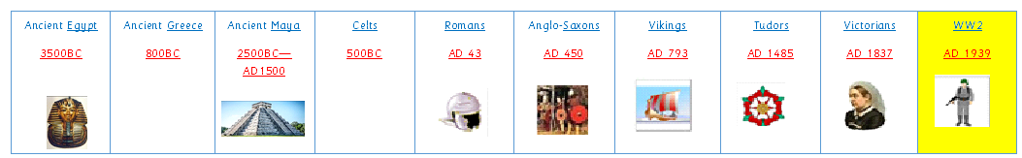

Key Knowledge:
To know that:
Þ World War 2 (WW2) started in 1939 and lasted till 1945.
Þ Some key events consisted of: The Blitz, evacuation, Battle of Britain, Dunkirk and D Day,
Þ D Day was a major turning point in the war: it was the largest amphibious invasion in human history.
Þ There were two world wars
Þ Germany was led by Adolf Hitler who was in charge of the Nazi Party.
Þ Hitler was voted into power in 1933 and wanted to restore German power after the First World War and the Treaty of Versailles.
Þ The main causes of WW2 were: German expansion of land; Germany breaching the Treaty after WW1 (creating a large army and mobilising troops); and the German invasion of Poland.
Þ Neville Chamberlain was the Prime Minister when Britain first joined the war.
Þ Winston Churchill succeeded Neville Chamberlain and led the country to victory.
Þ The war was fought by two sides, The Axis and The Allies.
Þ The war was fought all over the world (Europe, Africa and Asia ).
Þ The United States of America joined the war in 1941, after the attack on Pearl Harbour; this changed the fate of the war.
Þ The Second World War finished when the Allies liberated Europe.

Year 4
Autumn 1

WW2
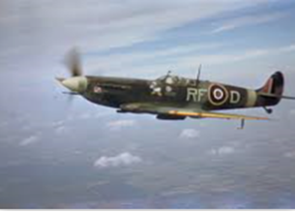
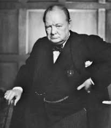
Key Dates / People:
Þ 1939-1945
Þ Neville Chamberlain
Þ Winston Churchill
Þ Adolf Hitler
Þ Allies/Axis

Key Vocabulary:
Treaty An agreement between countries
Allies Countries working together
Axis The group of countries who opposed the Allies.
Propaganda Information used to promote an idea or point
of view.
Persecution The mistreatment of a group or individual
usually because of their religion, gender or
ethnicity.
Liberation To free or release
Rationing Limiting the amount of food and items that
each person can buy
Invade To forcefully enter a country

