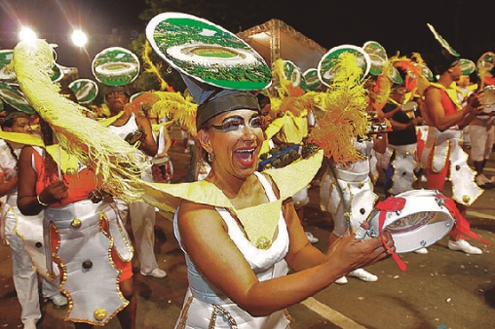
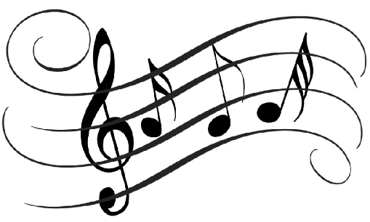
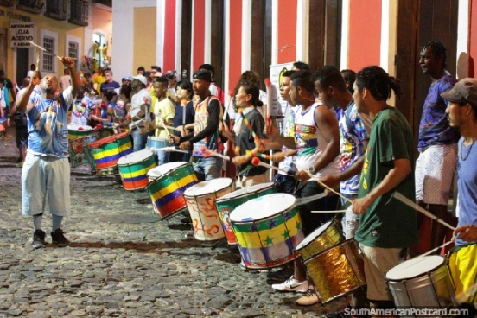

Key Knowledge:
To know that:
· Different amounts of layers in the music affect the texture of the music.
· A Buzz or a drag is a technique used to create a different sound on a drum.
· Breaks in the music are directed by the leader on the repinique.
· Samba originates from Rio de Janeiro in Brazil.
· The repinique, surdo, Caixa, tamborim, agogo bells and ganza make up the samba band.
· Samba Batucada is the rhythm played at Rio de Janeiro Mardi Gras, the world's largest street parade.
· Breaks are signalled by different sounds on the whistle or hand signals.
· Breaks are used to highlight different sections as solos.
· Syncopated (off the beat) rhythms are a characteristic of South American music.
· Samba music is built up of ostinatos; a rhythm that is played repeatedly.
· The structure of Samba Batucada consists of different breaks and the main pattern which is called the groove.

Samba
Year 6
Autumn 1

Key Vocabulary:
· Call and Response: Songs or instrumental pieces where the leader sings/plays a short phrase and everyone responds. Sometimes the response is a copy of the call, sometimes it is different.
· Rhythm—different patterns of long and short sounds
· Beats— the pulse of the music.
· Repinique, surdo, Caixa, cajon, agogos and tamborim.—the different names of the samba instruments.
· Skin shots - playing on the skin of the drum
· Rim shots— playing on the edge (rim of the drum
· Crotchet - a one beat note.
· Quaver - a half beat note
· Rest— a one beat rest.
· Notation- how music is recorded in visual form.
· Syncopation—off the beat patterns
· Drag/buzz— dragging the stick across the drum skin.
· Thumb break—a complete change in the music introduced by the whistle.
· Fusion—two or more types of music are combined.
· Groove—the main section of the music.

