
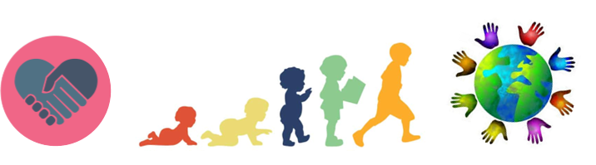


Key Knowledge:
To know that:
· The outcomes of risk-taking in a given situation can vary from serious to mild and can involve physical and emotional injury
· Ways to overcome problems and challenges include being patient, asking for help and trying a different way.
· An emotional risk could be something that upsets you and a physical risk is something that causes you injury
· People have aspirational goals and that actions need to be set to achieve these.
· The five ways to wellbeing are: to connect, be healthy, take notice, keep learning and be active.
· The five ways to wellbeing contribute to a healthy lifestyle and there are various ways to implement them
· There can be risk factors in a given situation.
· A risk can be reduced; by thinking before they act
· There are risks related to growing up and explain the need to be aware of these.

Being My Best
Year 6
Autumn 1

Key Vocabulary:
implementation—to start using a plan or system
achievement— a result gained by effort
contribute—to give something e.g money/time/ideas
success—to have a good or favourable result; do well.
media— a way of communicating to many people
relevant—related to what is being discussed or is presently important
risk - a chance that something bad or unsafe might happen.
social norms—beliefs and actions that are seen as acceptable within society
consequences—something that happens as a result of a person's action, inaction or poor decision
benefits—an advantage or profit gained from something.
cooperation: working together and helping each other to get something done.
enterprise—a plan or project that is risky, bold, or difficult to carry out
documentary—a film, which shows real events or provides information about a particular subject.

