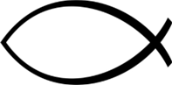
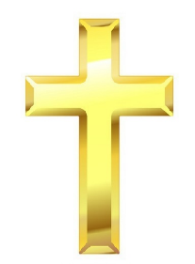


Key Knowledge:
To know that:
Þ The Bible is a Big Story and where ‘People of God’’ fits in to the timeline.
Þ Moses is an important leader in Christianity.
Þ Moses’ life story is in the Bible.
Þ Christians follow Moses’ example today and see him as a role model..
Þ The Ten Commandments are key ‘rules’ of Christianity and what they mean.
Þ Christians use the Ten Commandments as a guide in modern life.
Þ Christians put their beliefs about how to live in to action in different ways, giving examples.

Christianity – People Of God
Year 6
Autumn 1

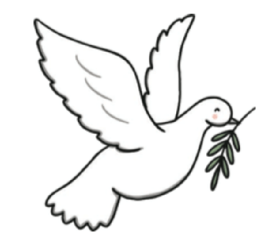
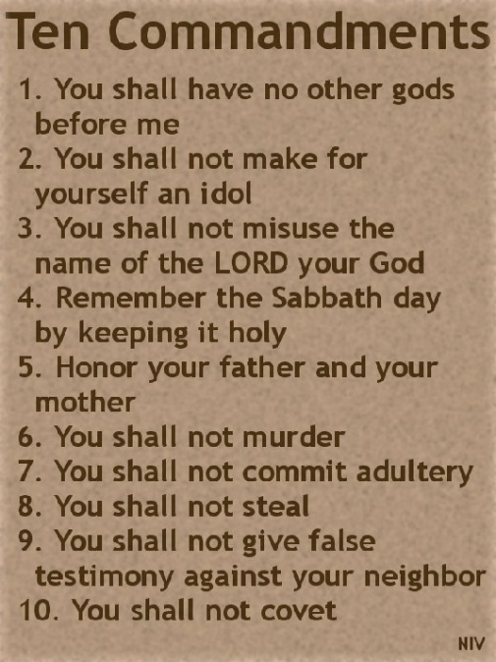

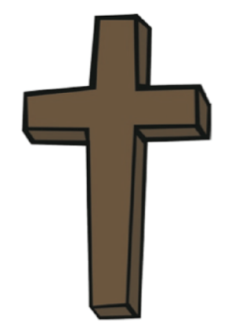
Key People:
⇒ Moses
⇒ Egyptians
⇒ Pharaoh
⇒ Hebrews
⇒ Israelites
Key Vocabulary:
Plagues a disastrous evil or affliction
a disease that affects humans and other mammals.
Ten Commandments Ten rules which show Christians and Jews how to
follow God’s teachings.
Mount Sinai The mountain where the 10 Commandments were
transcribed.
Charity Giving help and support to those in need.
Christians People who follow Christianity.
Old Testament The first book in The Bible.
Freedom The power to speak, behave and think as you want.
Salvation being saved from sin and becoming ‘right’ with God.

