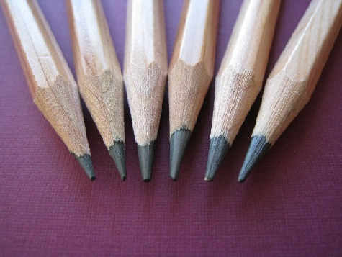

Key Knowledge:
To know that:
Þ Portraits can be realistic (realism, hyperrealism), impressionistic or abstract.
Þ The features of a face are often drawn in proportion.
Þ Annotating famous portraits helps me to express my thoughts and ideas.
Þ Highlights represent areas which receive more light
Þ Mid-tones represent areas that receive less light
Þ There are different styles of drawing (e.g. hyperrealism) which have different characteristics.
Þ These artists all have different styles of drawing: LS Lowry, Kathe Kollwitz, Arinze Stanley and Ginny Grayson
Þ Hyperrealism resembles a high-resolution photograph
Þ Impressionism gives an 'impression' rather a realistic picture
Þ Abstract art does not try to represent things as they look naturally.

Pencil Portraits
Year 6
Autumn 1

Key Vocabulary:
Þ light areas in a drawing where light is present
Þ tone/s changes from (white) light to mid (greys) to dark (black)
Þ mid tones areas of grey between black and white
Þ shadow/s areas where light is limited
Þ highlight/s light (white) areas of a drawing
Þ pencil grades numbers that show the hardness of pencil lead from 8B (very soft) to 2H (hard) and all the grades in between
Þ hatching a series of parallel lines used to create shade
Þ crosshatching horizontal, vertical or diagonal lines that cross over each other to create shade
Þ Drumstick grip - using the side of the pencil
Þ shading creating areas of shadow using pencils
Þ portrait a picture of the face
Þ expression the creation of individual ideas
Þ line a mark that joins different points. These can vary in length, width, direction and shape and can be used for different purposes
Þ stippling showing tone, shade or texture by drawing dots
Þ scribbling showing tone, shade or texture by drawing random, often continuous, lines
Þ pattern a design in which line, shape, form or colour is repeated

