
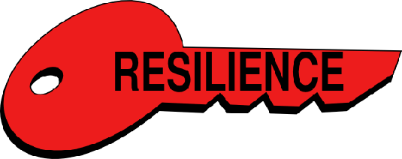

Key Vocabulary:
Grit - being able to keep working toward a goal and overcoming obstacles, even when it's hard.
Growth Mindset - believing you can get better at something and learn new skills by practising.
Personal Best - you best ‘score or attempt’ at a particular activity. Avoid comparing against others as it’s personal to you.
Year 6 - Autumn 1 & 2
Resilience
Key Knowledge:
To know that:
Þ Use a variety of techniques and strategies (such as breathing exercises, collaborating with a teammate) to keep emotions under control and so they don’t affect performance.
Þ Evaluate and select a technique(s) or strategy(ies) which works best for each individual to keep emotions under control.
Þ Use multiple attempts, if needed, to learn a new skills or achieve a target whilst remaining positive
Þ Understand ‘personal best’ is more important than current ability.
Þ Embrace and welcome moments of failure or disappointment as opportunities to reflect and learn about how to improve performance.

