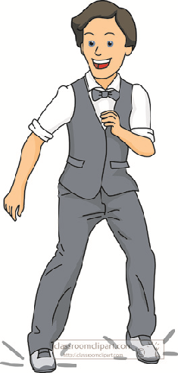
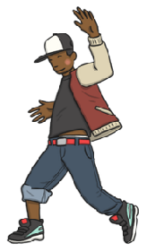

Key Vocabulary:
Language specific to particular dance styles, e.g. pavane, haka
Action and reaction– a particular dance move is performed which causes another move to happen straight after
Form, e.g. AB, ABA, ABAC-The shape, structure, or contour of a composition according to a preconceived plan.
Artistic intention-choosing which moves or action to include in a sequence to share a particular emotion as much as possible
Year 6 - Autumn 1 & 2
Dance
Key Knowledge:
To know that:
Þ Facial expression can communicate emotion and character in a dance.
Þ Contrast in a dance creates interest for the audience.
Þ A dance sequence should have a clear start and finish point.
Þ Dance movements can be sequenced to tell a story.
Þ Characters can interact within a dance.
Þ Transitions are used to link one dance movement to another.
Þ Professional dancers maintain and improve their skills by practising regularly.

