
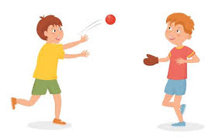

Key Knowledge:
To know that:
Using double movements can create space from the opponent
Both verbal communication (calling for the ball) or non verbal (hands up) should be used
I have a side-on position when defending so I am aware of where both opposition and ball are
I need to constantly scan around and behind to be aware of where the space is in relation to defenders
It is important to use sharp and concise communication, before entering space, to make teammates aware when you are ready to receive the ball

Key Vocabulary:
Disguise—Pretending to do one thing when in fact you are going to do another.
Communication—sharing and receiving ideas and feelings
Double movement - doing two movements in different directions in quick succession
Year 6 - Autumn 1 & 2
Passing & Space

