
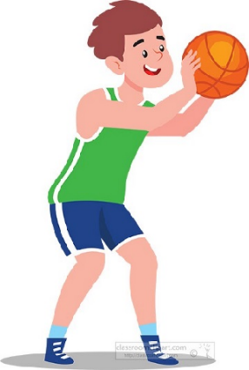

Key Knowledge:
To know that:
Receiving a rolling ball by lunging forward with one hand is much quicker than squatting down with both legs bent
Use someone’s name before sending a ball to ensure the person receiving is ready
Looking around before receiving the ball helps you make a quick decision about who should receive the ball next.
Using both slow, quick, long, short movements to create space makes it harder for an opponent to predict where you are going to move to

Key Vocabulary:
Lunge - a movement with one leg in front of the other, stepping towards the ground.
Ready position - knees slightly bent, body faced ball and hands cushioned in front
Accurately—reaching an intended target
Year 6 - Autumn 1 & 2
Sending & Receiving

