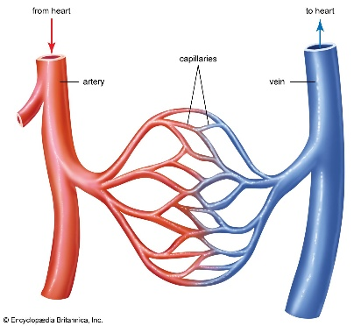

Circulatory System
Key Knowledge:
To know that:
- The heart pumps blood around the body.
- Blood carries oxygen and nutrients around the body.
- Exercise can help keep the heart and lungs healthy.
- There are several types of blood vessels:
- Capillaries are small vessels where oxygen and carbon dioxide are exchanged.
- Arteries carry oxygenated blood AWAY from the heart.
- Veins transport deoxygenated blood back TO the heart.
- Platelets help the blood to clot as a means to heal a wound and to cease blood loss.
- A pulse (measured by feeling an artery) indicates the heart rate.
- Exercise will affect your pulse and respiratory rate due to an increased demand of oxygen.
- The lifestyle choices a person makes will impact how their bodies function.

Year 6
Autumn 1

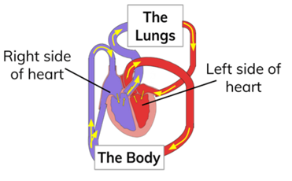
Key Vocabulary:
- respiration—the act of breathing that causes the exchange of oxygen and carbon dioxide
- inhalation (breathing in)
- exhalation (breathing out)
- artery (a blood vessel that carried blood AWAY from the heart)
- capillary (tiny blood vessels connecting arteries to veins. These blood vessels carry oxygen and nutrients to individual cells throughout the body)
- vein (a blood vessel that carries blood back TO the heart)
- gas exchange (the delivery of oxygen from the lungs to the bloodstream, and the elimination of carbon dioxide from the bloodstream to the lungs)
- Pulse (the beating of your heart that you can feel in the arteries in your neck or wrist)
- Lungs (the organ where gas exchange occurs)
- Heart (the organ which pumps your blood around your body)
- Oxygen (the gas we inhale)
- Carbon Dioxide (the gas we exhale)
- Circulatory system (this includes the heart and all the vessels which pump the blood around the body.
- fair test - a scientific test where one factor is changed and everything else stays the same
- diet— the type of foods which humans or animals usually eat
- nutrition— the process of eating healthy food for living and growing
- independent variable – something that might be changed in an experiment
- dependent variable – something that might be measured in an experiment

